|  |
| --- |
|  |
| Space Gallery |
| *NASA Pictures app* |
|  |
| **Aarathi R** |
| **2/17/2020** |

Table of Contents

Introduction 3

Required Configuration 3

Application Structure 3

# Introduction

This application uses a gallery-grid-like presentation to display NASA pictures and provides more details about the pictures on clicking them. Once the user is connected to an active network, application loads the pictures in few seconds and the user can scroll through them as they like.

# Required Configuration

1. Mobile phone running on Android 8.0 or higher version
2. Active network connection
3. Internet permissions
4. External Storage Read-Write permissions

# Application Structure

1. When the user opens the application for the first time, it displays a loading screen until all images are loaded and then displays the same in the grid-structure.

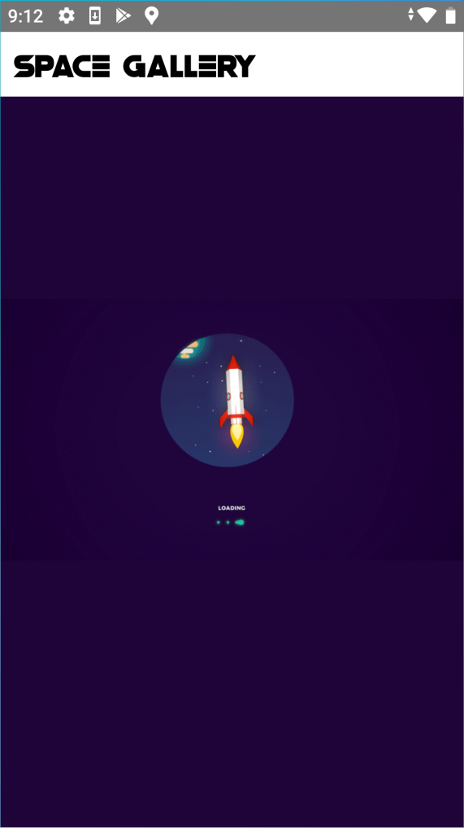

1. The main screen of the application displays all the pictures in a grid-layout and user can scroll down revealing more pictures. The grid can be scrolled up and down as the user pleases to check out the pictures.

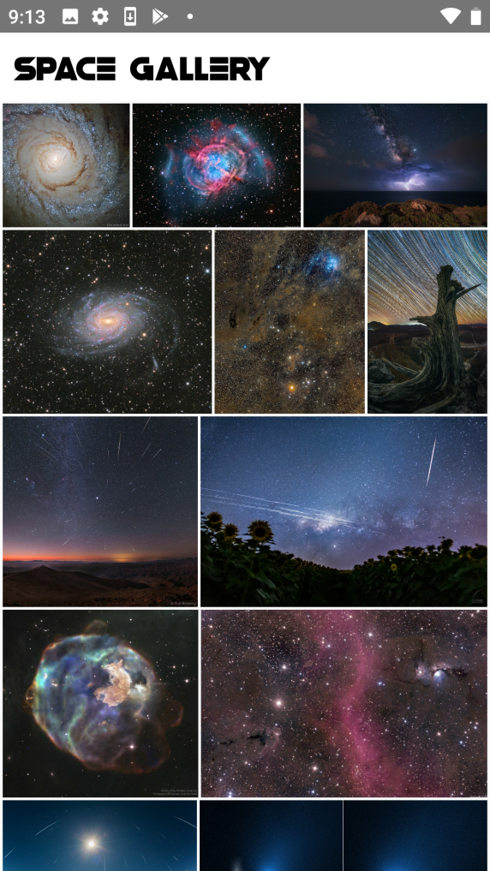 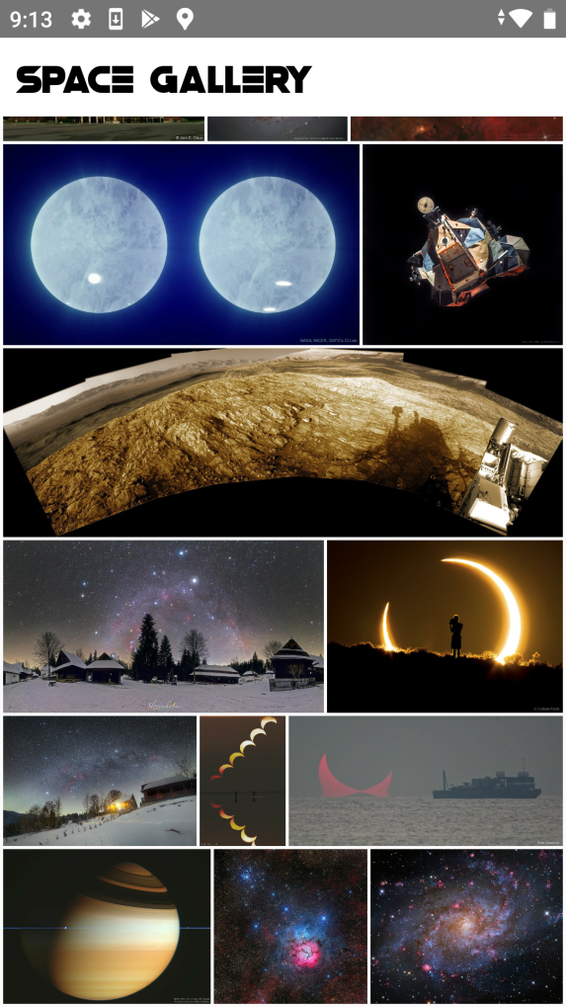

1. Once the user clicks on a picture, it takes you to another screen where an enlarged version of the picture is displayed with a scroll-up layout below that reveals further details about this picture, such as the title, the content explanation etc.

